Assignment 2

**Source Code 1:**

const readline = require('readline');

// Create an interface to read input from the user

const rl = readline.createInterface({

input: process.stdin,

output: process.stdout

});

// Function to find the mode

const findMode = (arr) => {

const frequency = {};

let maxFrequency = 0;

let mode = null;

arr.forEach(num => {

frequency[num] = (frequency[num] || 0) + 1;

if (frequency[num] > maxFrequency) {

maxFrequency = frequency[num];

mode = num;

}

});

return mode;

};

// Function to prompt the user to enter the numbers

const promptForNumbers = () => {

rl.question('Please enter the numbers separated by commas: ', (input) => {

// Convert input string to an array of numbers

const numbers = input.split(',').map(num => num.trim());

// Validate the input to ensure all entries are numbers

const areAllNumbers = numbers.every(num => !isNaN(num));

if (areAllNumbers) {

const numberArray = numbers.map(Number);

// Find and output the mode

console.log(`The mode is: ${findMode(numberArray)}`);

rl.close(); // Close the readline interface

} else {

console.log('Invalid input. Please enter only numbers separated by commas.');

promptForNumbers(); // Prompt the user to enter the numbers again

}

});

};

// Start the prompt

promptForNumbers();

**Source Code 2:**

const swapKeysAndValues = (obj) =>

Object.fromEntries(Object.entries(obj).map(([key, value]) => [value, key]));

// Example usage:

const input = { "N": "M", "w": "This is String", "c": 4};

const output = swapKeysAndValues(input);

console.log(output);

**Source Code 3:**

const multiply = (callback, num1, num2) => {

const result = num1 * num2;

callback(result);

};

// Example usage:

const printResult = (result) => {

console.log("The result is:", result);

};

multiply(printResult, 13232, 332324);

**Source Code 4:**

const numbers = [120, 209, 230, 340, 550];

// Task 1: Double each number in the array using an arrow function

const doubledNumbers = numbers.map(num => num * 2);

// Task 2: Log each doubled number along with its index using template literals

doubledNumbers.forEach((doubledValue, index) => {

console.log(`The doubled value of number at index ${index} is ${doubledValue}.`);

});

**Input and Output for Source Code 1:**

Input and Output 1:



Input and Output 2:



Input and Output:

**Input and Output for Source Code 2:**

Input 1:

Output 1: 

Input 2:



Output 2:



Input 3:



Output 3:



**Input and Output for Source Code 3:**

Input 1:



Output 1:



Input 2:



Output 2:



Input 3:



Output 3: 

**Input and Output for Source Code 4:**

Input 1:



Output 1:

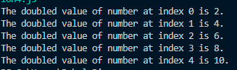

Input 2:



Output 2:

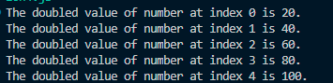

Input 3:



Output 3:

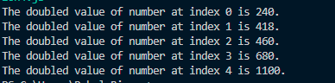

**Remarks:**

Solution 1 requires a Node package to be installed in order to run, as it uses some Node package methods like require.